Case Study: Advantages of Using AI in Government and Public Sector
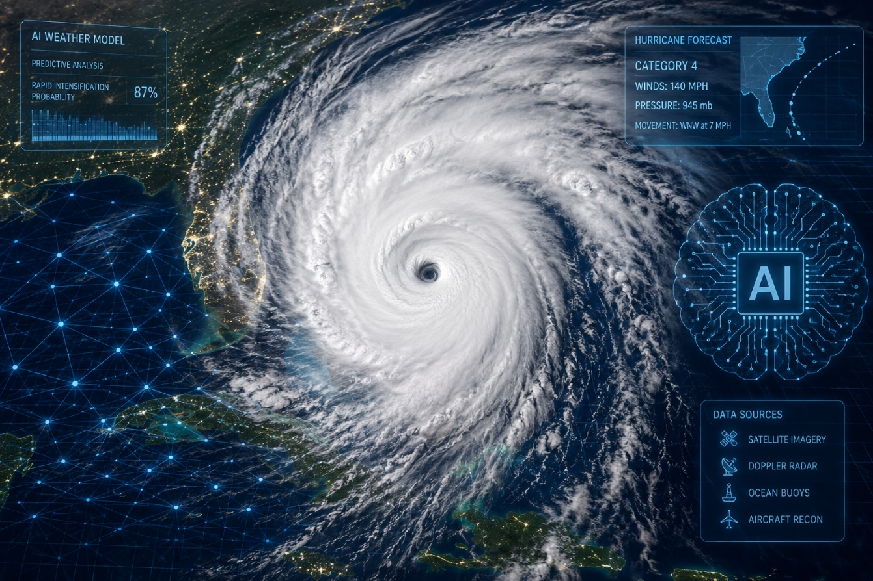
A Case Study on NOAA's AI-Enhanced Hurricane Forecasting

Rich Fox
ITAI 2372 – Artificial Intelligence Ethics
Houston Community College – Applied AI & Robotics Program
July 11, 2026

Introduction
Government agencies are starting to use artificial intelligence (AI) to speed things up. One of the clearest examples is hurricane forecasting. For years, meteorologists have gotten pretty good at predicting where a hurricane is headed. But predicting how strong it will get, especially when it blows up in strength right before landfall, has been one of the toughest problems in weather science. For people living on the Texas Gulf Coast, that's not just a science problem. It's the difference between prepping for a moderate storm and getting blindsided by a monster one.
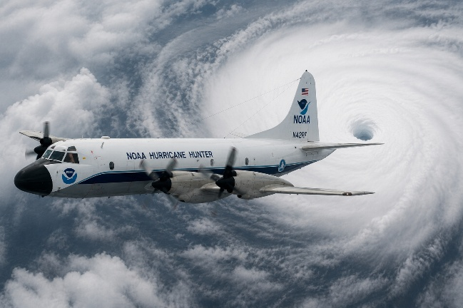
This report looks at how NOAA and the National Hurricane Center (NHC) have started using AI models to forecast hurricanes, especially through a partnership with Google DeepMind during the 2025 Atlantic hurricane season. It looks at what worked, what didn't, and uses Hurricane Melissa as the main example. Then it proposes a new idea: taking this AI forecasting a step further to give Gulf Coast communities more useful, personalized storm warnings.

Case Study Analysis: AI in NOAA Hurricane Forecasting

The Problem
Hurricane track forecasts, meaning where a storm is going, have gotten better and better over the decades. But intensity forecasts, meaning how strong a storm gets, have not kept up. Rapid intensification is when a storm's wind speed jumps by at least 35 miles per hour in just 24 hours. It's happening more often as ocean temperatures rise, and it's dangerous because it can catch people off guard. Older weather models work by simulating the physics of wind, moisture, and heat moving through the atmosphere. They've historically struggled to capture the fine details inside a storm that drive these sudden jumps in strength. That means less warning time for emergency managers and residents, which is a big problem on the Gulf Coast, where warm water can fuel a storm right up until it makes landfall.

AI Tools and Techniques Implemented
During the 2025 season, NHC forecasters added AI guidance to their usual lineup of models, which already includes NOAA's own Hurricane Analysis and Forecast System (HAFS). The big addition was WeatherNext, a model built by Google DeepMind and Google Research. Unlike the older models, WeatherNext doesn't simulate atmospheric physics directly. Instead, it's trained on decades of historical weather data plus data on extreme past hurricanes, and it runs 50 different simulations at once to give forecasters a range of likely outcomes instead of just one guess. At the same time, NOAA rolled out its own new lineup of AI weather models, which the agency says are faster, more accurate, and use way less computing power than the old models. NOAA has also started using machine learning to clean up radar data collected by its Hurricane Hunter aircraft, pulling more usable data out of each flight.

Outcomes and Benefits
- Historic rapid-intensification call: WeatherNext correctly predicted Hurricane Melissa would blow up into a Category 5 storm five days before it happened. That was the first time NHC had ever forecast a storm reaching Category 5 starting from Category 1 wind speeds.
- More warning time: Because forecasters trusted that early call, Jamaican officials got extra time to move resources and start evacuations before landfall. That's the whole point of better forecasting: more time to act.
- AI came out on top: By the end of the season, NHC's own report found the AI models, led by WeatherNext, gave the best track and intensity forecasts of any single model that year.
- Cheaper and faster: NOAA's new AI models produce forecasts using a lot less computing power than the old physics-based models, so guidance gets to forecasters and the public faster.
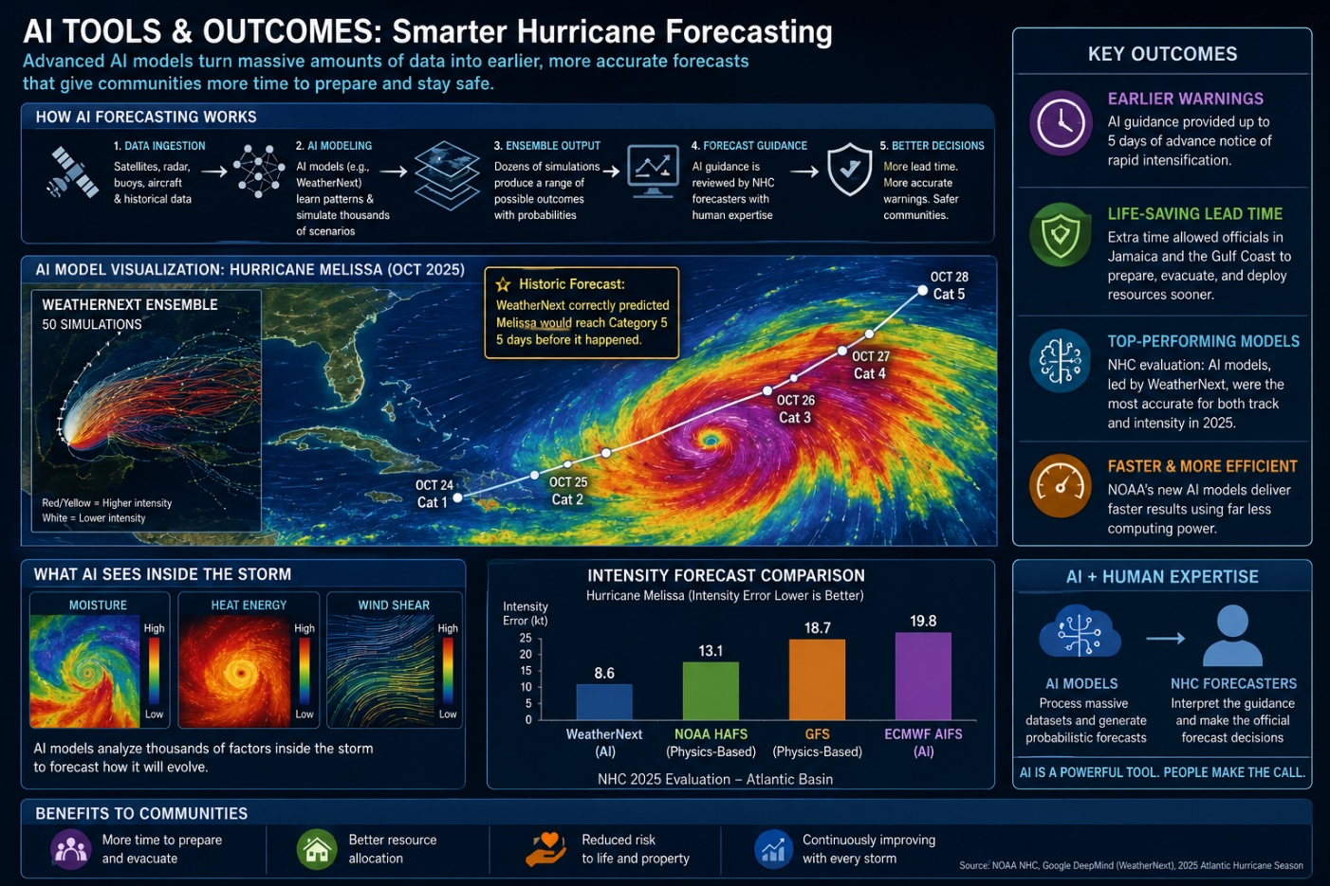

Challenges and Limitations
- Not every AI model is good: Some AI models flopped. One European AI model barely beat a coin flip on intensity because it was trained on data that tends to weaken storms too fast, giving it a built-in bias toward underestimating strength.
- Trust takes time: NHC forecasters have said openly that it took a couple of full hurricane seasons of watching these models perform before they felt comfortable leaning on them. Part of the reason is that AI models are more of a black box than the older physics-based ones.
- AI is a tool, not a replacement: Senior NHC forecasters are clear that no AI model nails every detail of a storm's track, strength, and structure. Human judgment and the older physics-based models still matter a lot.
- Good forecasts aren't the whole story: Even a great intensity forecast doesn't automatically tell you what storm surge, wind damage, or flooding will look like on the ground. That still takes more modeling and local know-how.
Put together, this shows a forecasting system that's genuinely changing for the better. AI has already delivered a historic, life-saving improvement in predicting rapid intensification. At the same time, forecasters are still working through real questions about how reliable these models are, how much they can be trusted, and how they fit alongside decades of physics-based forecasting experience.
Element | Summary
Agency | National Oceanic and Atmospheric Administration (NOAA) and the National Hurricane Center (NHC), in partnership with Google DeepMind
Problem Addressed | Hurricane intensity forecasting, especially rapid intensification, has long lagged behind track forecasting in accuracy, leaving coastal communities with too little warning before a storm suddenly strengthens near landfall
AI Tools/Techniques | Google DeepMind's WeatherNext model (GDMI), an AI ensemble trained on decades of global weather data and historical tropical cyclone intensities; NOAA's own new suite of operational AI-driven global weather models (AIGFS); machine learning for quality-controlling Hurricane Hunter tail Doppler radar data
Outcomes | WeatherNext correctly forecast Hurricane Melissa's rapid intensification to Category 5 five days in advance, giving Jamaica unprecedented lead time; AI models were the top-performing guidance for both track and intensity across the 2025 Atlantic season; lower computational cost and faster delivery of forecasts
Key Challenges | AI models still make errors and cannot yet resolve fine-scale storm structure or downstream impacts; some AI models underperform on intensity due to biased training data; forecasters are still building trust in outputs they cannot fully explain; AI is a supplement to, not a replacement for, physics-based models and human judgment
Table 1. Summary of the NOAA/NHC AI hurricane-forecasting case study.

Innovative Proposal: Hyperlocal AI Storm Alerts for Gulf Coast Communities

The Issue
The Hurricane Melissa case shows AI can now give forecasters days of extra warning before a storm blows up in strength. But that better regional forecast doesn't automatically reach individual households in a way they can actually use. Gulf Coast communities, including plenty along the Texas coast, are big, low-lying, and don't all have the same resources. A county-wide evacuation map or a general hurricane watch doesn't tell one specific family in one specific flood-prone neighborhood how much time they really have or what they should do about it. That's the gap this proposal is trying to close: getting a more accurate national forecast down to the personal, local level people actually need to act on it in time.

Proposed Application
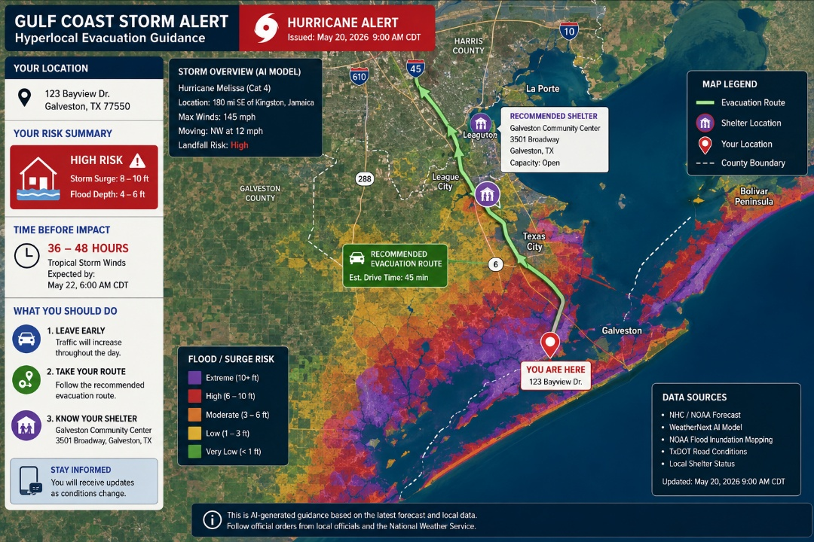
This report proposes a system that sits downstream of NOAA's forecasting work rather than trying to replace it: a hyperlocal AI storm-alert platform. It would take in NHC and WeatherNext-style forecasts, plus NOAA's flood-mapping data and local info like road capacity and shelter locations, and turn all of that into a risk score for a specific address. Instead of a generic county-wide bulletin, a resident would get a plain-language alert telling them their storm-surge and wind risk, roughly how much time they have before things get bad, and a suggested evacuation route and shelter based on real-time road and shelter data.
Figure 1 shows how this would work. Storm data, including satellite, radar, and NHC/AI model guidance, first goes through an AI step that turns the regional forecast into local risk. Then a human emergency-management reviewer checks that guidance before alerts actually go out to the affected neighborhoods. Just like NOAA and NHC do today, a person stays in the loop before anything is sent. That keeps someone accountable for a decision this important, while still getting the speed and precision AI adds.
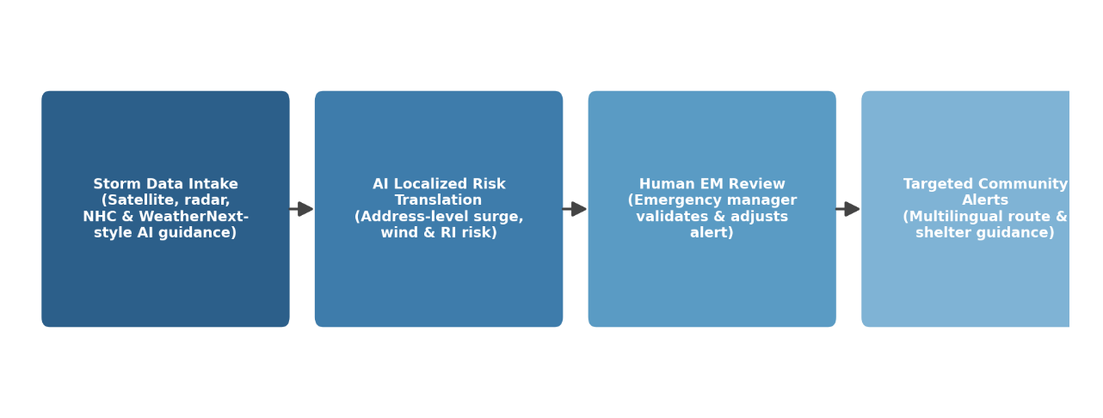
Figure 1. Proposed workflow for the hyperlocal Gulf Coast storm-alert platform.
Dimension | Current State | With Proposed Platform
Intensity/RI alerting | Regional NHC advisories issued for large coastal stretches | AI-driven rapid-intensification risk translated to neighborhood-level alerts
Storm surge & flood risk | Flood Inundation Mapping available but not paired with personalized guidance | Address-level surge and inundation risk pushed directly to residents
Equity of reach | Warnings rely heavily on broadcast media and English-language alerts | Multilingual text/app alerts prioritized for mobile-home parks, flood-prone, and low-connectivity areas
Evacuation guidance | General county-level evacuation zone maps | AI-personalized route and shelter suggestions based on real-time road and shelter capacity data
Table 2. Current regional storm warning approach compared with the proposed platform.

Justification and Expected Outcomes
This idea builds directly on what the case study shows works: AI's ability to catch rapid intensification early. It also fixes something the case study doesn't solve on its own, which is getting that extra warning time down to the household level. Expected results include more useful warnings for people in flood-prone or under-resourced neighborhoods, evacuation timing based on a family's actual situation instead of a countywide average, and multilingual, mobile-first alerts that reach people broadcast news might miss. Because this platform builds on top of NOAA's guidance instead of replacing it, it gets better automatically as NOAA's own AI models improve.

Anticipated Challenges
- Pulling the data together: Combining NHC and AI forecasts with local road, shelter, and demographic data in real time during a fast-moving storm is a real technical challenge.
- False alarms: Too many alerts and people start ignoring them. Too few and people don't get warned in time. Getting that balance right is critical.
- Who gets left out: An app or text-based system could miss households without reliable phones or internet, which is exactly the kind of gap this platform is supposed to close.
- Staying in sync: Any local alert would need to line up with, not contradict, official National Weather Service and county warnings, so people aren't getting mixed messages during a crisis.

Conclusion
NOAA's 2025 hurricane season shows that AI can close one of the biggest gaps in disaster forecasting: catching rapid intensification early enough to matter. Hurricane Melissa is a clear example. An AI model gave forecasters days of extra warning for a storm that ended up being one of the strongest ever recorded. At the same time, the case study shows that even a great forecast still needs human judgment, careful checking, and backup from physics-based models, and that AI's benefits aren't spread evenly across every model or every community yet. The hyperlocal alert platform proposed here takes that unevenness on as the next problem to fix, turning a better national forecast into personal, useful guidance for the Gulf Coast households who need it most. As AI forecasting keeps improving, the next challenge for public-sector AI isn't just predicting the storm better. It's making sure that better prediction actually reaches everyone in time to act on it.

References
Freedman, A. (2025, December 3). The best hurricane forecasts of 2025 came from an AI model. CNN. https://www.cnn.com/2025/12/03/climate/hurricane-forecast-melissa-ai-prediction-rapid-intensification
Google DeepMind. (2026, May 19). AI breakthrough: WeatherNext predicts Hurricane Melissa. https://deepmind.google/blog/how-weathernext-helped-the-national-hurricane-center-better-predict-hurricane-melissas-historic-landfall-in-jamaica/
Lowry, M. (2026, June 23). AI weather models changing the hurricane forecast game. https://michaelrlowry.substack.com/p/ai-weather-models-changing-the-hurricane
National Fisherman. (2026, June 5). NOAA predicts 'below normal' 2026 Atlantic hurricane season. https://www.nationalfisherman.com/national-international/noaa-predicts-below-normal-2026-atlantic-hurricane-season
National Hurricane Center. (2026). Hurricane Melissa tropical cyclone report (AL132025). National Oceanic and Atmospheric Administration. https://www.nhc.noaa.gov/data/tcr/AL132025_Melissa.pdf
National Oceanic and Atmospheric Administration. (2026, February 17). NOAA deploys new generation of AI-driven global weather models. https://www.noaa.gov/news-release/noaa-deploys-new-generation-of-ai-driven-global-weather-models
National Weather Service. (n.d.). AI in hurricane forecasting at the National Hurricane Center. https://www.weather.gov/news/261102-AI-Hurricane-Forecasting
Quantum Zeitgeist. (2026, May 20). WeatherNext spots Hurricane Melissa's 35+ MPH rapid intensification. https://quantumzeitgeist.com/weathernext-spots-hurricane-melissas-mph/
WKMG ClickOrlando. (2026, March 31). The future of forecasting: AI emerges as top hurricane model in 2025. https://www.clickorlando.com/weather/2026/03/31/the-future-of-forecasting-ai-emerges-as-top-hurricane-model-in-2025/

